Client–Server Architecture
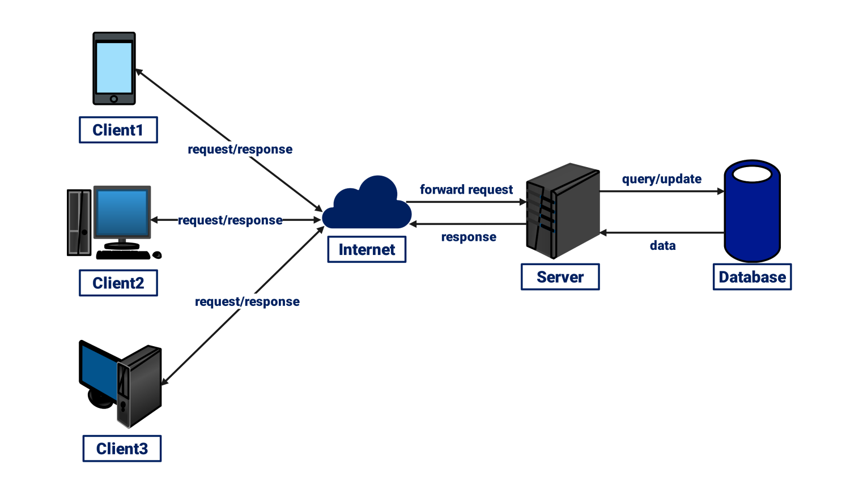

Client–Server Architecture
Client–Server architecture is a network model in which a client (user computer or web browser such as Internet Explorer) sends a request to a server. The server processes the request and sends the required response back to the client.

Components of Client–Server Architecture
- Client: The user's computer or browser that sends requests to the server.
- Server: A powerful computer that stores websites, applications, and databases and responds to client requests.
- Network/Internet: The communication medium that connects the client and server.

Working Principle
- The client sends a request to the server.
- The server receives and processes the request.
- The server sends the response back to the client.
- The client displays the result to the user.

What Happens When You Open a Website
- Step 1: Enter URL – The user enters a website address such as www.example.com in the browser.
- Step 2: DNS Lookup – The browser contacts the Domain Name System (DNS) to convert the domain name into an IP address.
- Step 3: Request to Server – The browser sends an HTTP/HTTPS request to the web server.
- Step 4: Server Processing – The server processes the request and finds the requested webpage files. • Step 5: Server Response – The server sends the webpage data (HTML, CSS, JavaScript) back to the browser.
- Step 6: Browser Rendering – The browser interprets the data and displays the webpage on the screen.

Conclusion
Client–Server architecture enables communication between a user's browser and a web server. When a user opens a website, the browser sends a request to the server, the server processes it, and the browser displays the webpage returned by the server.

